Purpose
To establish a procedure on how to dictate and gross gastrectomy specimens for gastric malignancies and/or CDH1 gene mutations.
Procedure
- Try to open specimen along the greater curvature and allow to fix in formalin overnight.
- Photograph the specimen as you will need to annotate where sections are taken (this is a must for CDH1 cases).
- Measure specimen and include any other anatomic structures i.e. distal esophagus, duodenum, peri gastric adipose.
- Document any abnormalities such as ulcers, masses, or thickened areas. Be specific on where the lesions are in the specimen i.e. body, pylorus, greater curvature, lesser curvature.
- Ink the serosa adjacent to any specific lesions identified.
- If a lesion is present, document depth of invasion within the gastric wall.
- Note any other secondary pathologies that may be visible.
- Palpate and dissect out any lymph nodes (16 lymph nodes are required for TMN staging).
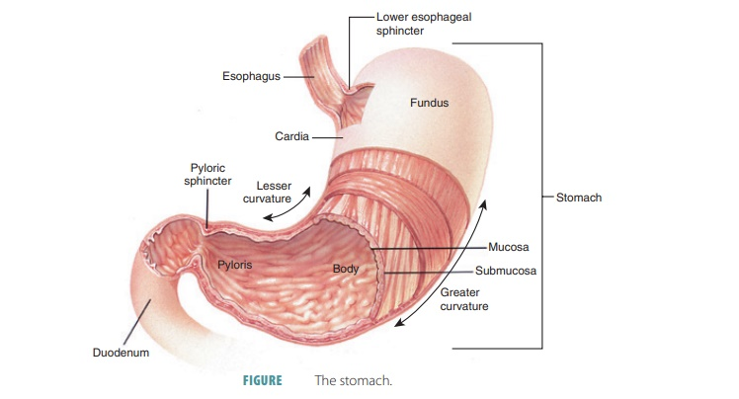
Figure 1. Gastric Anatomy https://www.pharmacy180.com/article/stomach-3697/

Sections for Histology- Grossly Evident Gastric Mass

- Shave and submit both proximal and distal margins of resection entirely.
- Submit approximately 1 section per cm of tumor to include greatest depth of invasion.
- Submit any other significant gross findings.
- Submit all lymph nodes. If 16 lymph nodes are not found, please submit up to 8 cassettes of peri gastric adipose.

Sections for Histology- Prophylatic for CDH1 Gene Mutatoins With No Evident Mass

- There is usually no mass grossly, but almost all of these will have microscopic foci of carcinoma in the gastric mucosa when sufficiently sampled (usually in body/fundus), so treat these as oncologic specimens. If carcinoma is not found in the submitted sections, the attending may ask for additional random sections.
- Shave and submit both proximal and distal margins of resection entirely.
- Submit any significant gross lesions.
- Submit all lymph nodes. If 16 lymph nodes are not found, please submit up to 10 additional cassettes of peri gastric adipose.
- If there is no obvious tumor, submit random sections for microscopic evaluation, as specified below. Sections should be about 2 cm in length, with 1-2 sections per cassette. Make sure sections are flat in the cassette since the complete mucosa needs to be seen microscopically.
  - 2 cassettes Cardia
  - 3 cassettes Antrum
  - 1 cassette Incisura angularis
  - 1 cassette Lesser curvature of body
  - 2 cassettes Greater curvature of body
  - 6 cassettes Fundus (sample both sides of fundus)
  - 12 cassettes Body (sample both sides of body)
*It’s imperative that you create a mapping diagram of the specimen and annotate where all cassettes are taken. See figure 4 below for example.

Sample Photographs/Annotations

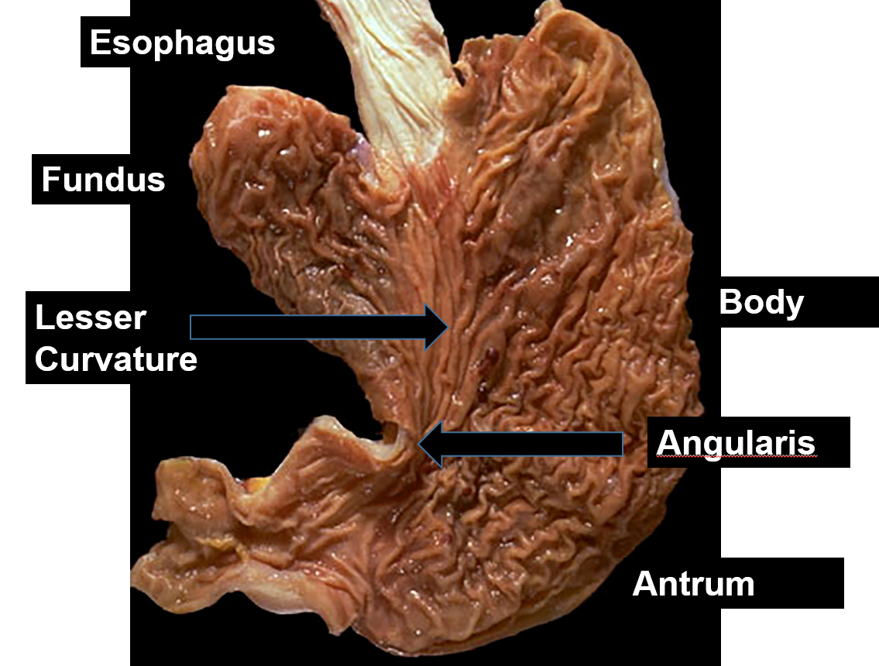
Figure 2. Gastric Anatomy

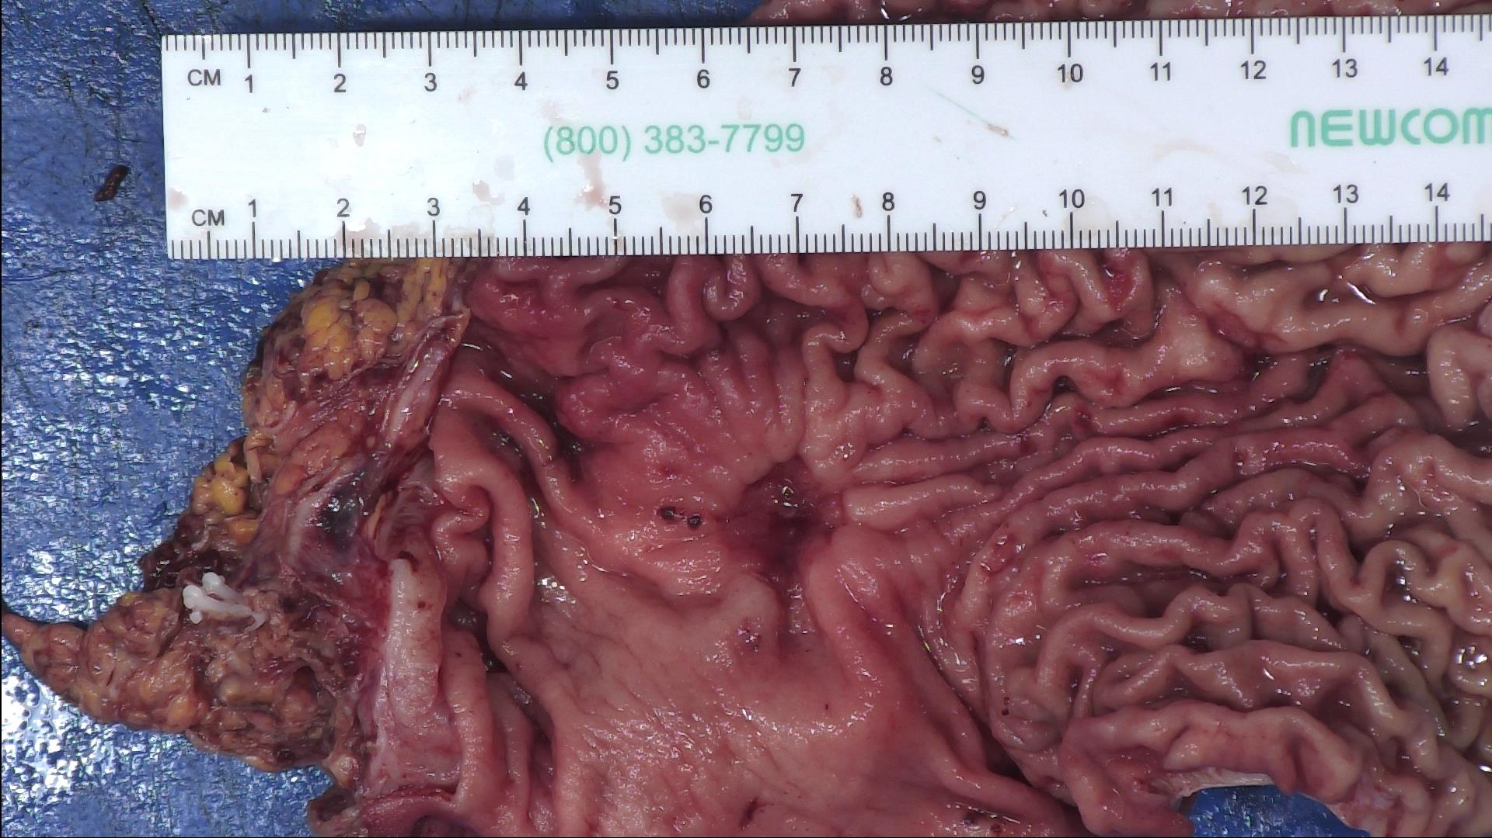
Figure 3. Thickened wall with infiltrating tumor and overlying ulcer

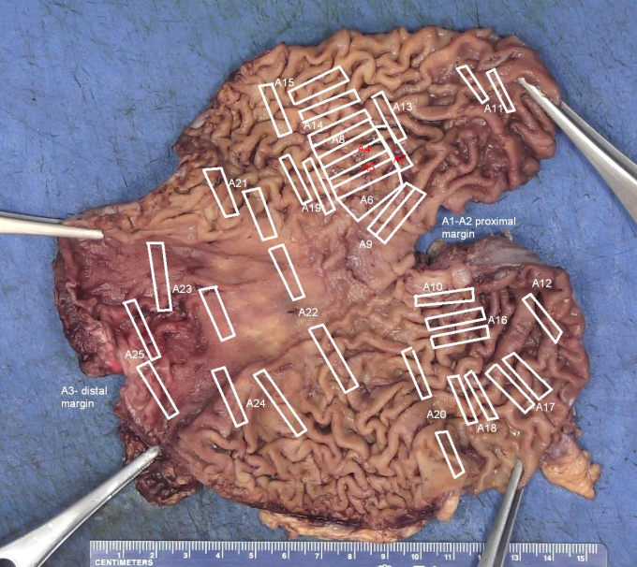
Figure 4. Mapping/Annotated diagram of CDH1 mutation gastrectomy

